**GenerationType:**

1. AUTO
2. IDENTITY
3. SEQUENCE
4. TABLE

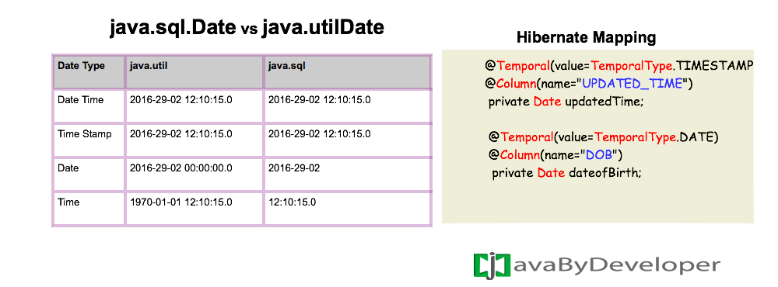

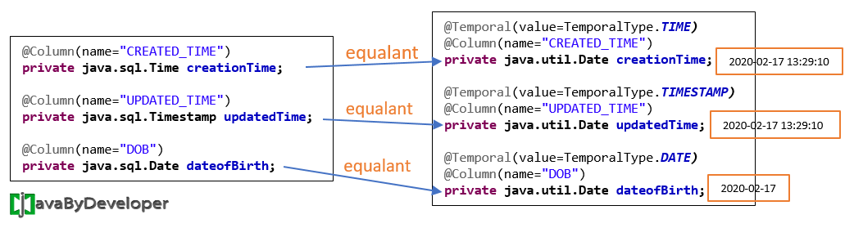

[https://javabydeveloper.com/temporal/]